
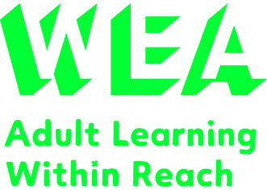
Friday 2nd February 2024
(to 1st March)
10am – 12.00pm
4 week course

Involve, Mint Lane Wellbeing Hub,
Lincoln, LN1 1UD
Fee: £33.60*
(*or FREE if you are in receipt of an income related benefit. You could also apply for Learner Discretionary Fund for a fee waiver if your household income is less than £21,000 a year).
You will need your own personal email address so that you’re able to login to the WEA’s digital learning platform: WEA Canvas.
To enrol please ring 0300 303 3464 with course ref Q00013563
or visit our website wea.org.uk

For further information please ring WEA Lincoln on 07502 641211

Employment Planning
This course is an introduction to person cantered planning, focusing on creating personal plans relating to employment. These are individualised documents that create a pathway for a person to achieve a goal, or employment.
Students will learn skills and techniques to make their plans relevant and understandable to them, these will be updateable and adaptable.
Looking at a variety of ways of to make these plans using different media and technology, and how these can help learners find meaningful and fulfilling employment.

Person Centered Planning for Employment

With Patrick O’Reilly
wea.org.uk
Supported by
The WEA is a charity registered in England and Wales
(no. 1112775) and in Scotland (no. SC039239).
wea.org.uk

