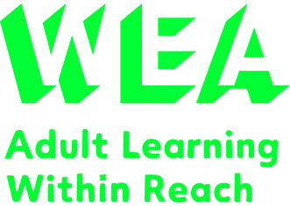


Supported by
The WEA is a charity registered in England and Wales
(no. 1112775) and in Scotland (no. SC039239).
Do you want to learn about basic digital skills in a friendly and supportive environment? You will learn about the basics of using a device, how to set up and use emails and how to successfully and quickly look for jobs online. Your tutor will give you clear and easy-to-understand instructions, along with tips on how to positively trouble shoot digital issues.
Digital Skills Beginners 
wea.org.uk

Every Friday for 4 weeks
19 April to 10 May 2024
12.30pm – 2.30pm

At Involve
Mint Lane Wellbeing Hub
Lincoln LN1 1UD

Fee: £33.60*
(*or FREE if you are in receipt of an income related benefit. You could also apply for Learner Discretionary Fund for a fee waiver if your household income is less than £21,000 a year).

You will need your own personal email address so that you’re able to login to the WEA’s digital learning platform: WEA Canvas.
To enrol please ring 0300 303 3464 with course ref Q00013489
or visit our website wea.org.uk

For further information please ring WEA Lincoln on 07502 641211

First Steps to Using a Computer

with Patrick O’Reilly

